PROJECT

1-

**Algorithm:**

1. Start
2. Get input from the user for x and y
3. Store the sum of x and y in a variable sum i.e., sum=x+y
4. Display the sum to the user
5. End

**Pseudocode:**

Start

input x

input y

sum=x+y

display sum

End

**Python code:**

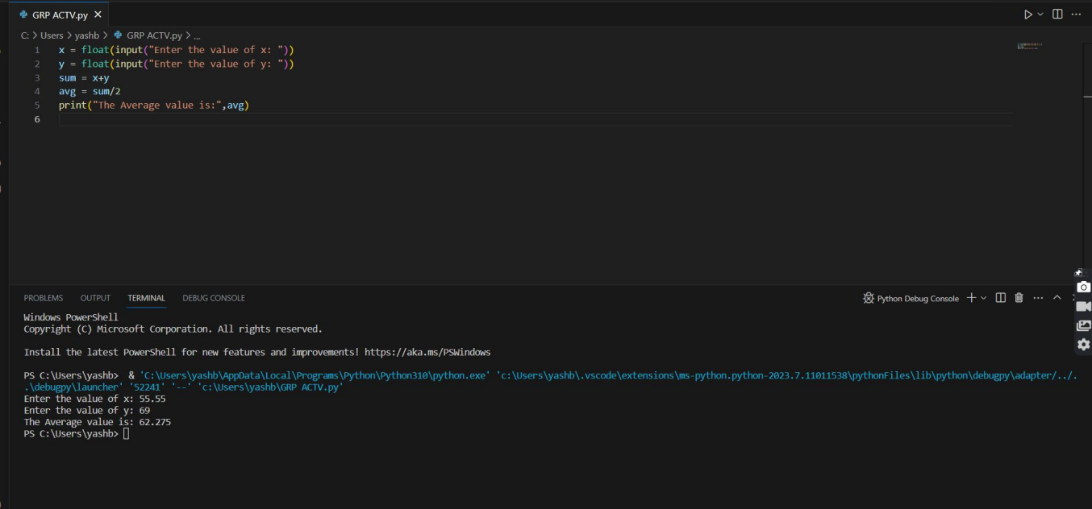

2-

**Flowchart:**

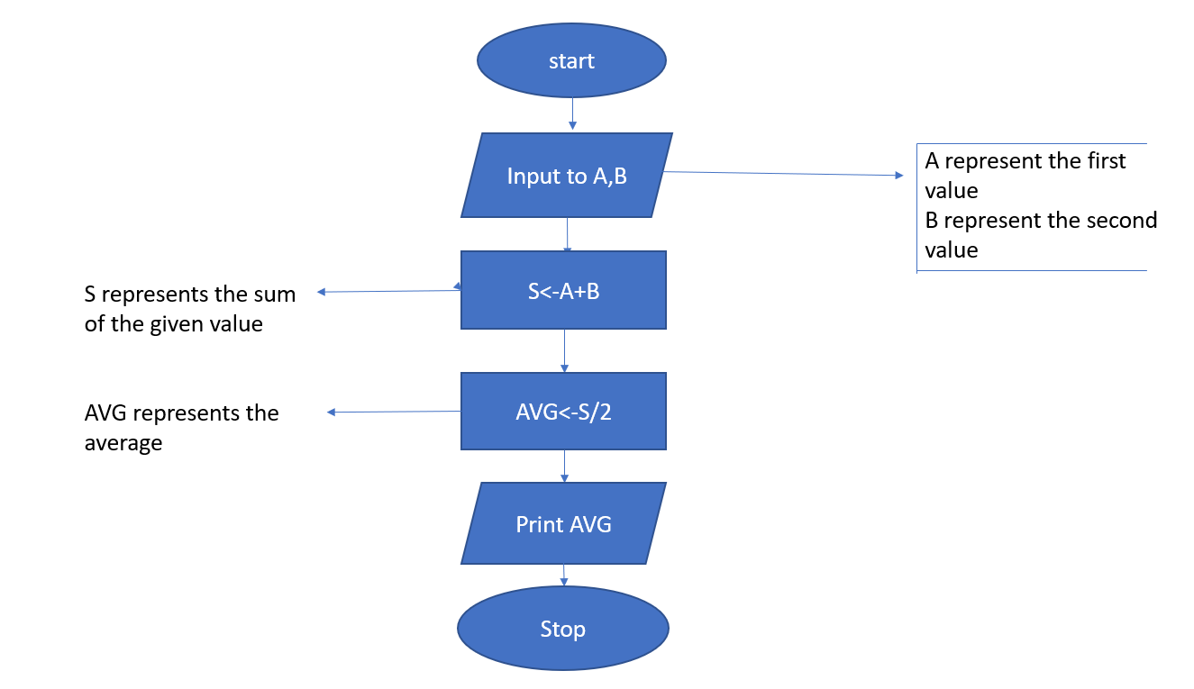

**Pseudocode:**

Start

Input x

Input y

sum=x+y

Avg=sum/2

Display Avg

End

**Python code:** 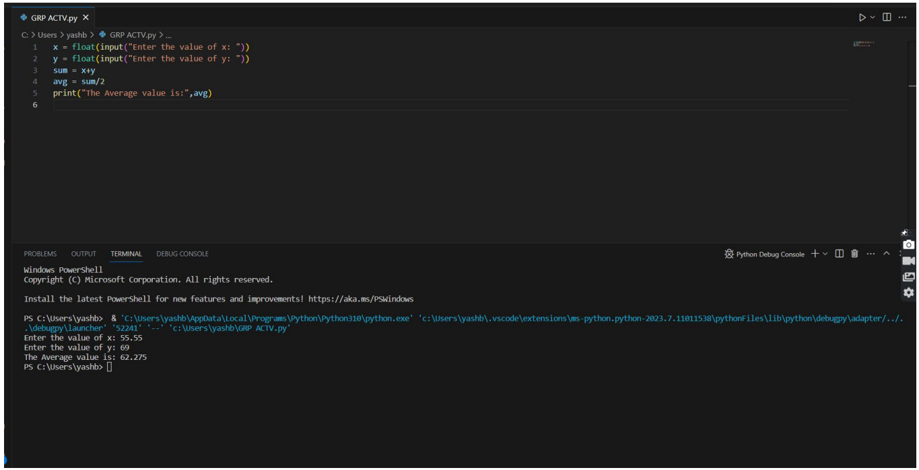

3-

**Flowchart:**

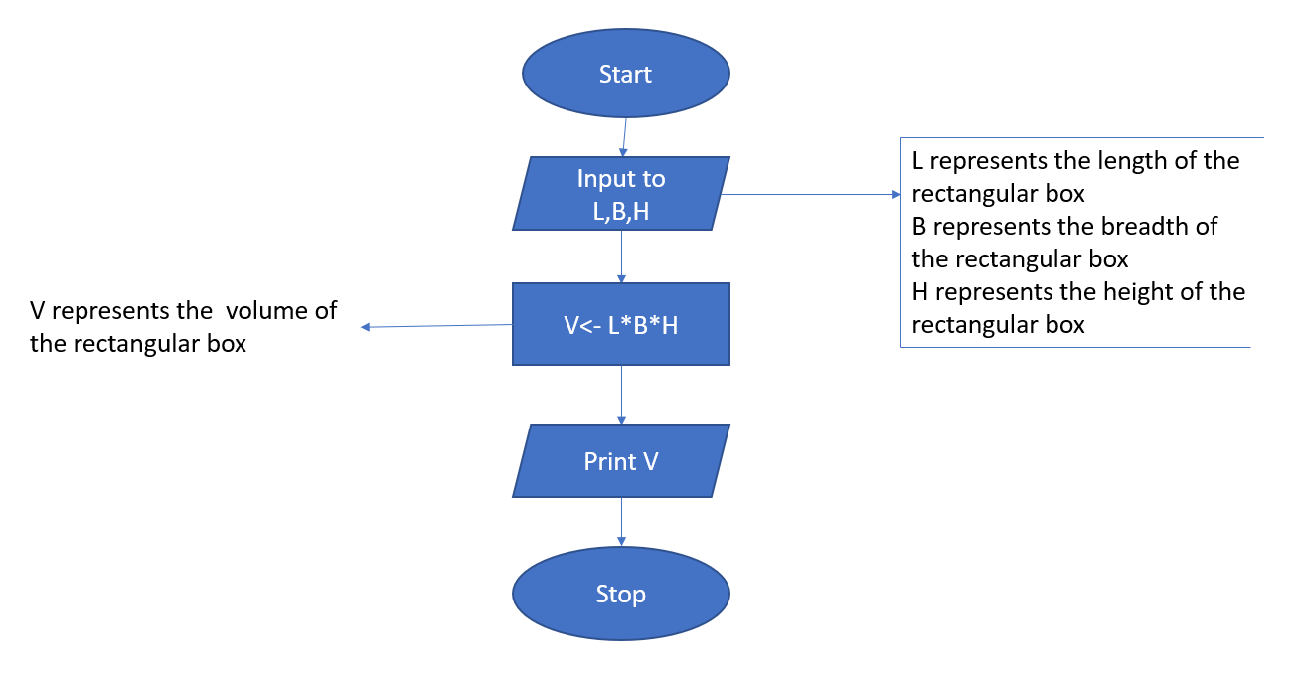

**Pseudo code:**

Start

Input length

Input breadth

Input height

volume=length*breadth*height

Display volume

End

**Python code:**

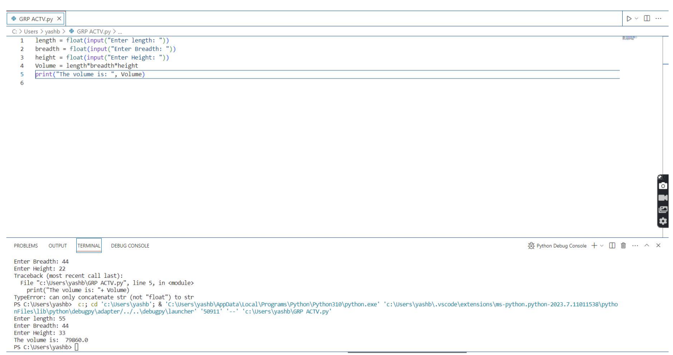

4-

**Algorithm:**

1. Start
2. Get the input from the user for the number of hours worked in a day and rate of pay for per hour
3. Calculate the wage by the formula, wage=hours*rate
4. Display the total daily wage to the user.
5. End

**Pseudo code:**

Start

input hours

input wage

wage = hours*rate

display wage

End

**Python code:**

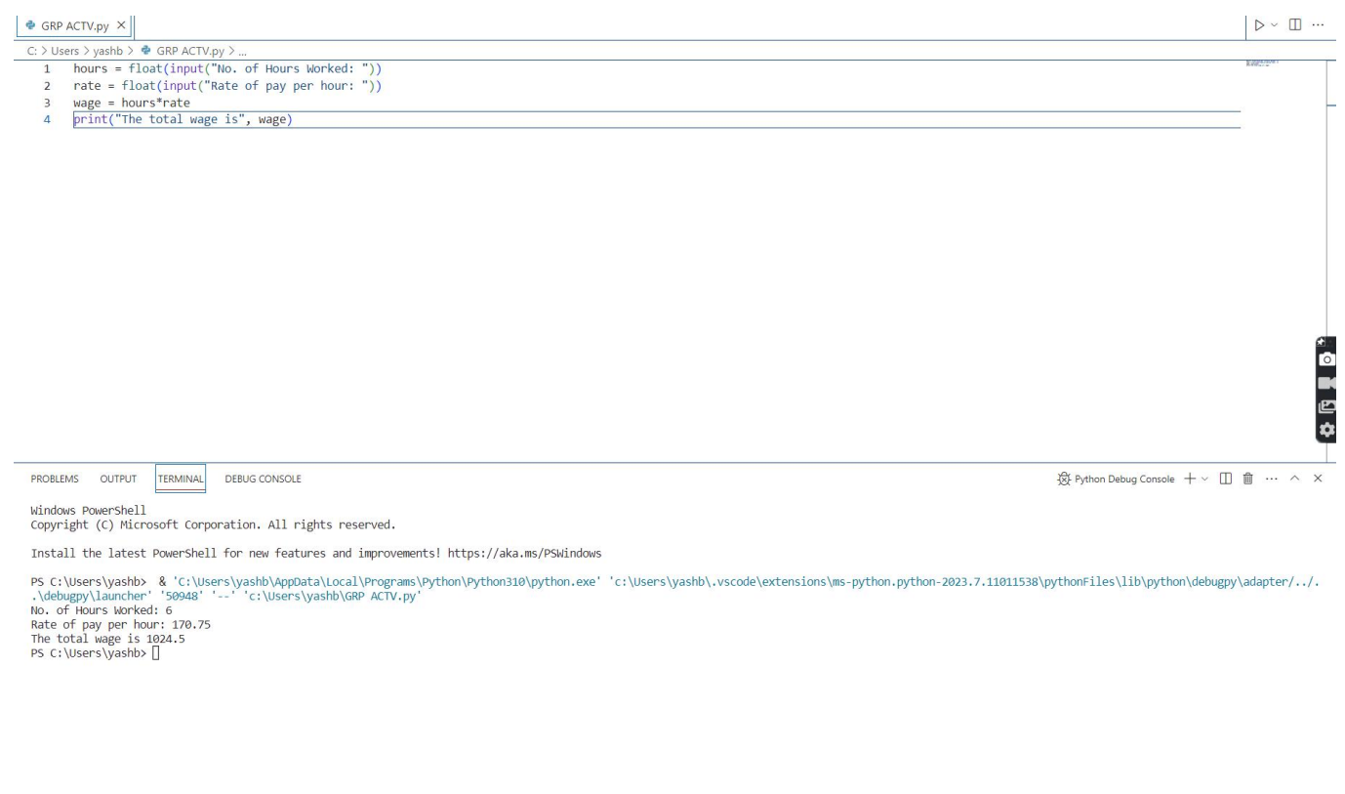

5-

**Flowchart:**

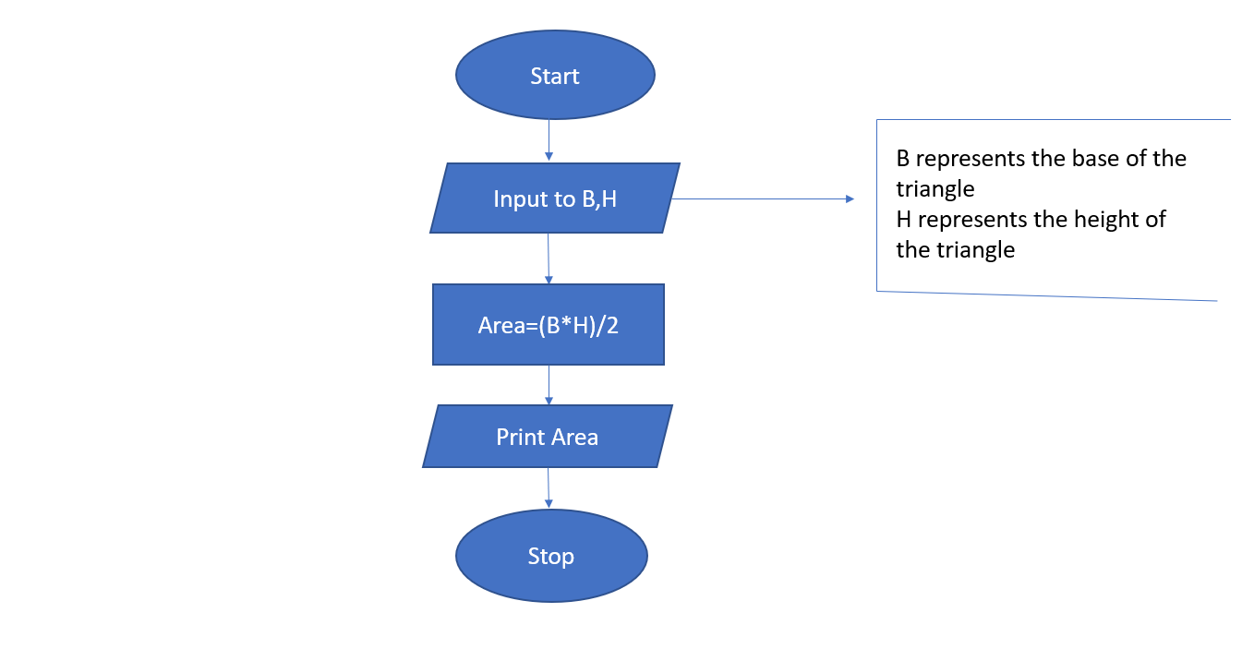

**Algorithm:**

1. Start
2. Input base and height
3. Calculate the area the using the formula: Area=0.5*height *base
4. Output the calculated area
5. End

**Pseudocode:**

Start

Input base

Input height

Area= 0.5*base*height

Output Area

End

**Python code:**

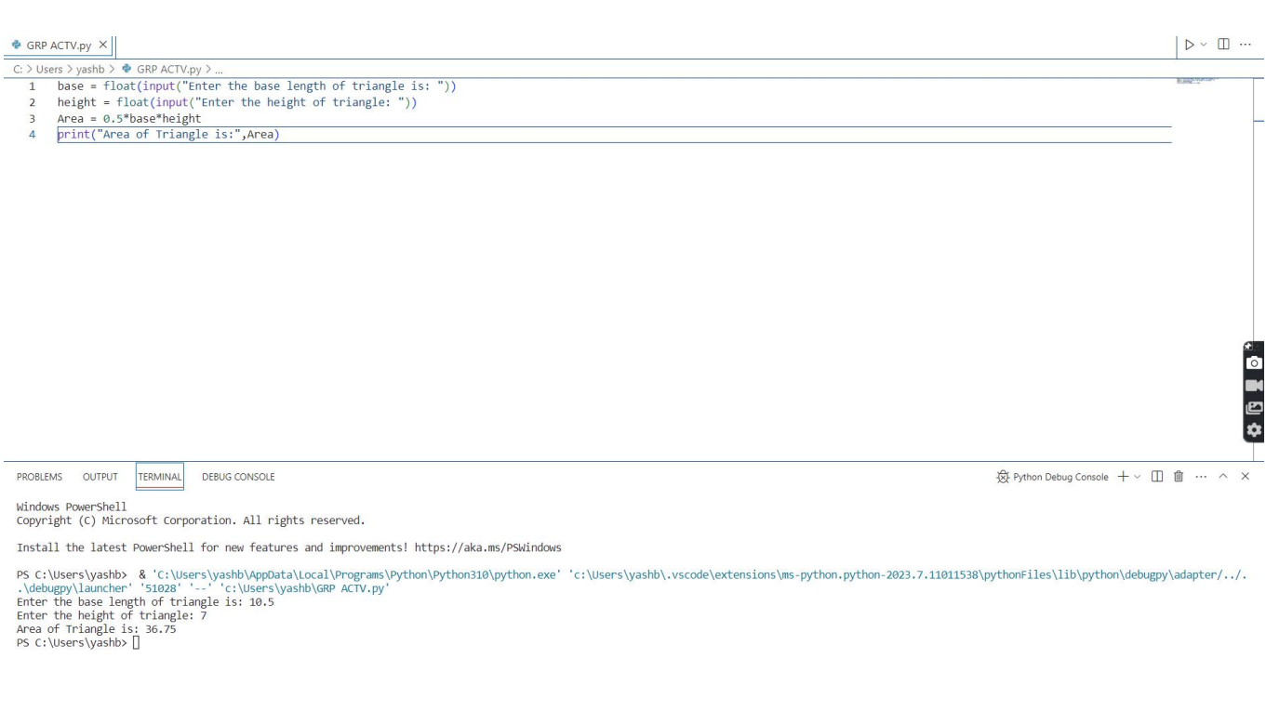

6-

**Flowchart:**

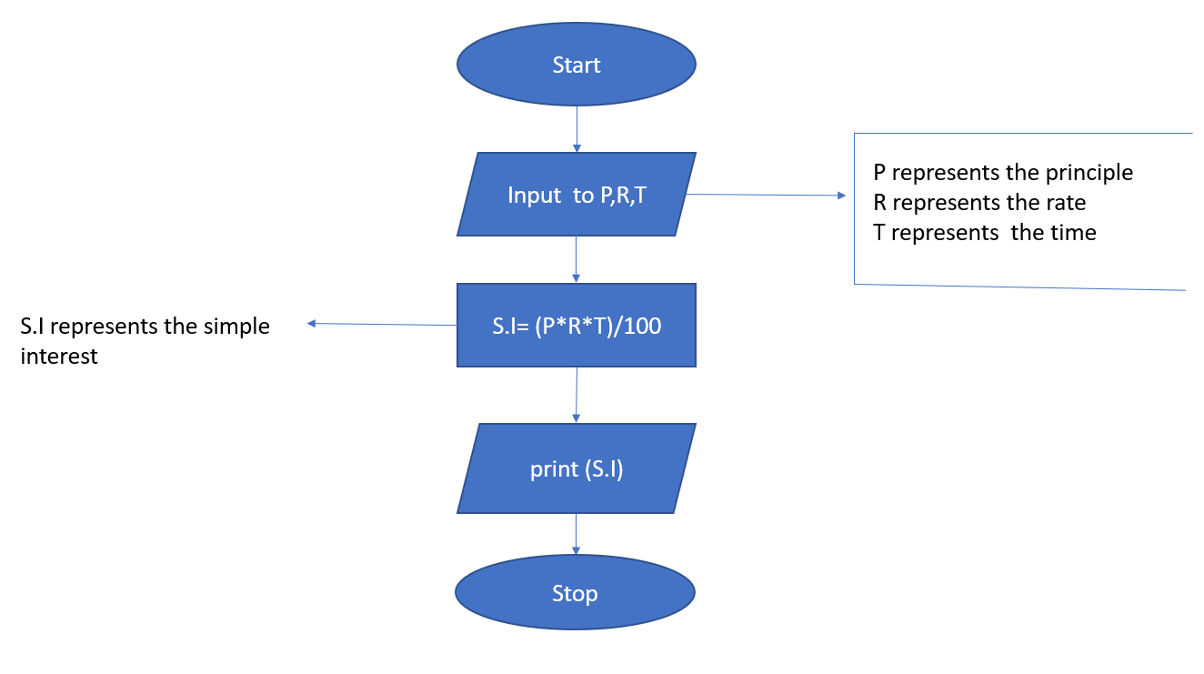

**Algorithm:**

1. Start
2. Input the principal amount, rate of interest and time period
3. Calculate the simple interest using the formula: Simple Interest= (Principle*Rate of Interest*Time Period)/100
4. Display the calculated simple interest
5. Stop

**Pseudo code:**

Start

Input P

Input R

Input T

Calculate Simple_interest = (P * R* T) / 100

Display Simple_interest

End

**Python code:**

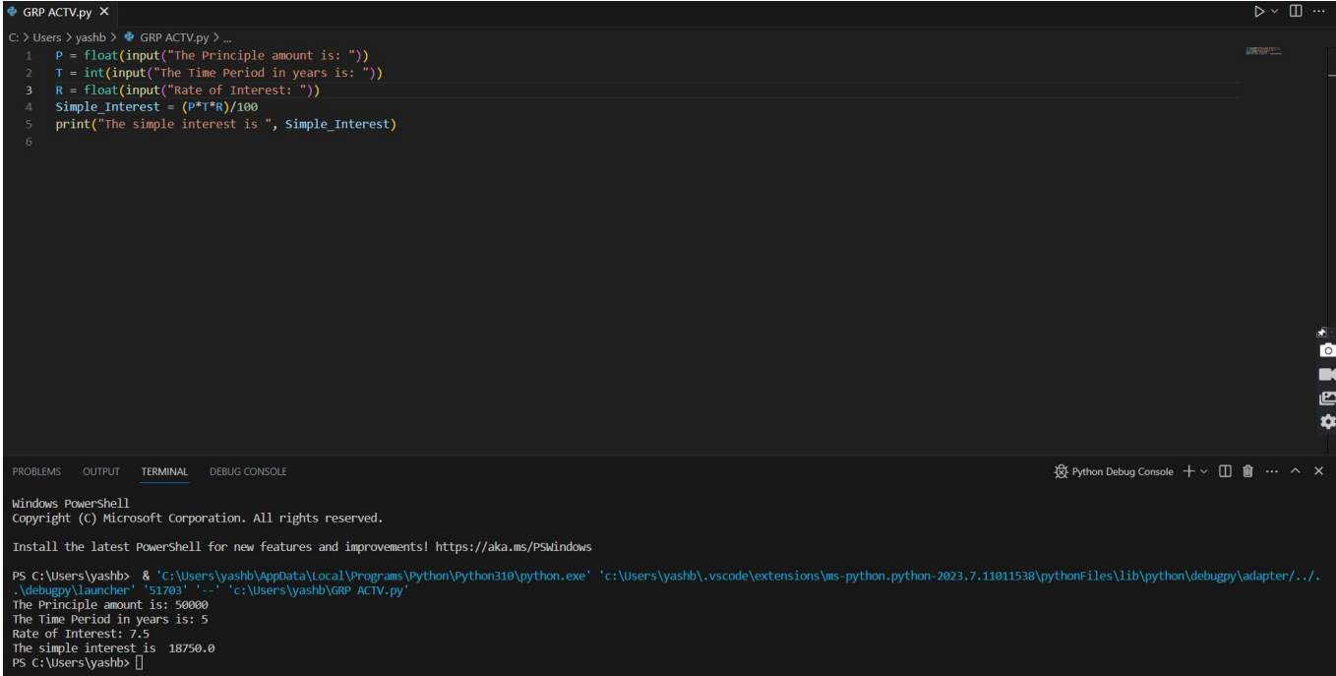

7-

**Flowchart:**

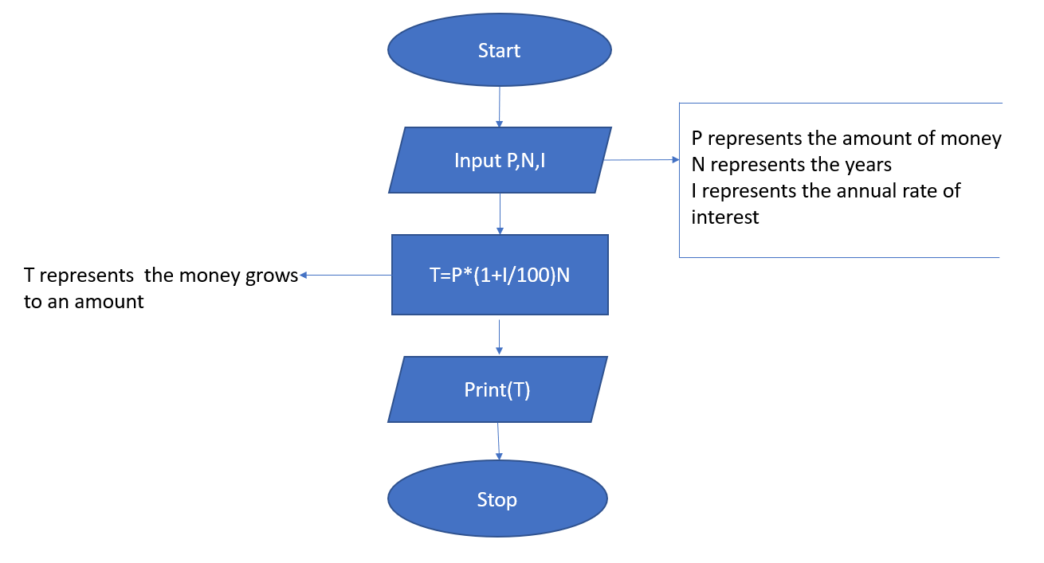

**Algorithm:**

1. Start
2. Read the value of P
3. Read the value of N
4. Read the value of I
5. Calculate T = P * (1 + I/100)^N
6. Display
7. End

**Pseudo code:**

Start

Read P

Read N

Read I

T = P * (1 + I/100) ^ N

Display T

End

**Python code:**

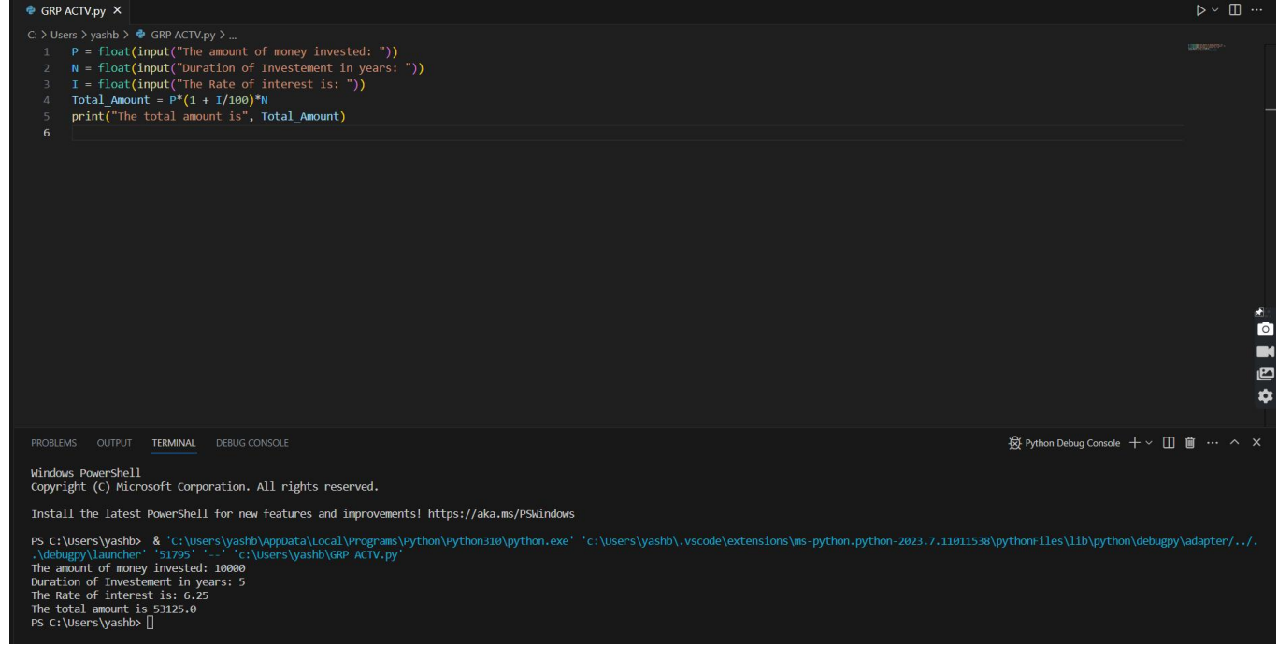

8-

**Flowchart:**

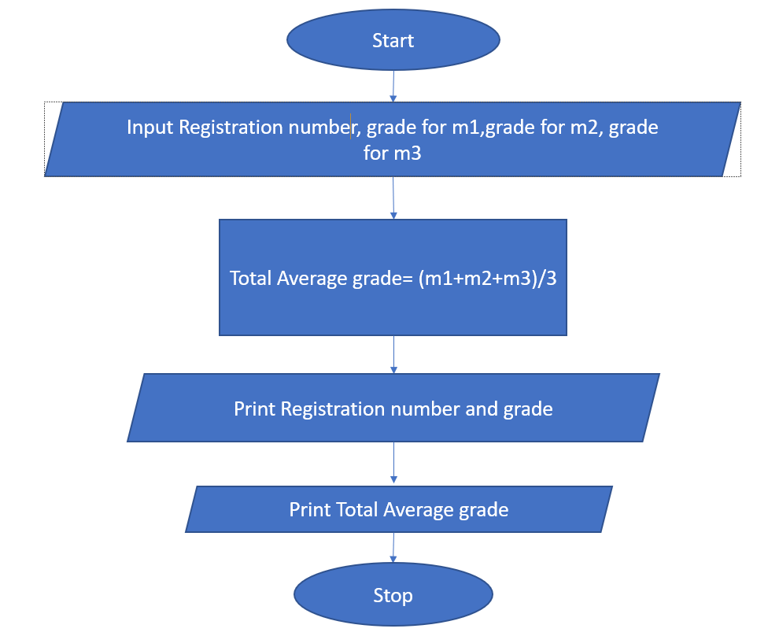

9-

**Flowchart:**

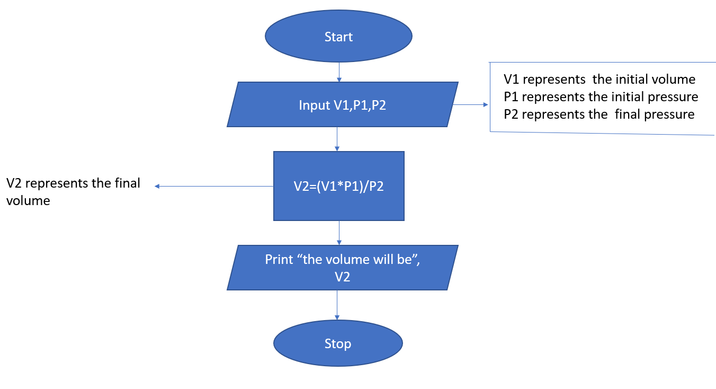

10-

**Flowchart:**

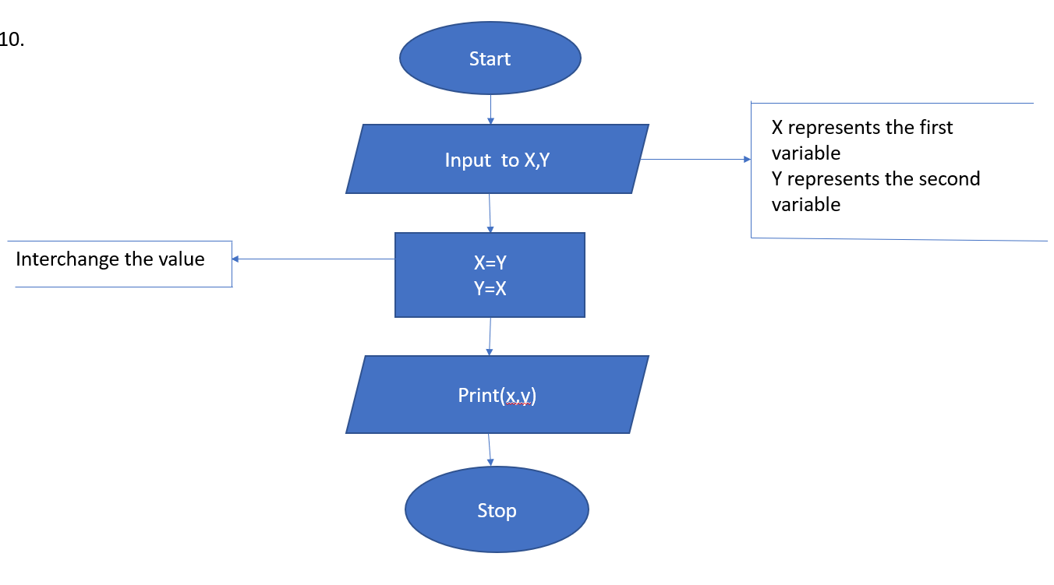

**Algorithm:**

1. Start
2. Input the values of variables x and y
3. Interchange the values of x and y by using comma operator as x,y=y,x
4. Print the new values of x and y
5. End

**Pseudo code:**

Start

Input x,

x,y = y,x

Print x, y

End

**Python code:**

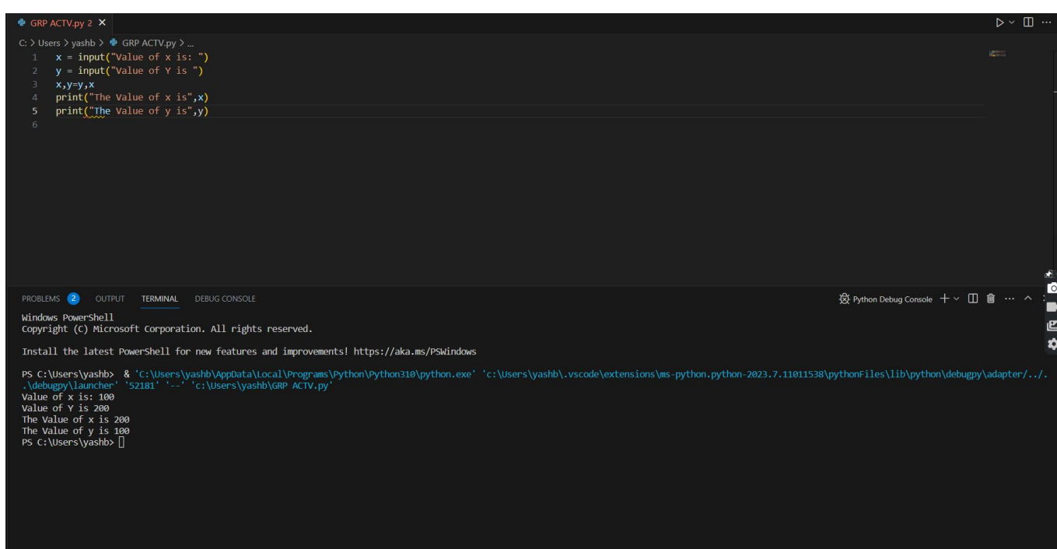

**By:-**

1. **Harshit Bihani 22BAI10249**
2. **Anushka Das 22BAI10336**
3. **Rhythm jain 22BAI10303**
4. **Sambhavi kansal 22BAI10134**
5. **Yashsingh Chauhan 22BCE11543**
6. **Shreya Dayal 22BAI10335**
7. **Aman Soni 22BAI10324**
8. **Anshika Bhatt 22BAI10355**